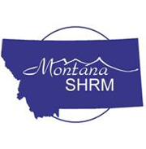
Montana Human Resource Leader of the Year Award

Submission Requirements

- Complete and submit the attached 2018 ballot describing the nominee's accomplishments according to the award criteria in 500 words or less
- Nominee must be a member of SHRM National or a Montana SHRM chapter
- Send nominations to MT SHRM Workforce Development Director, Ronda Wakefield, by 5 p.m. on March 23, 2018
- The State Council does not limit the number of nominations received
- State Council members will vote on all entries by April 6, 2018
- If a council member is nominated, he or she will not cast a vote
- The Montana SHRM State Council Chair will announce the award winner and present the winner with an engraved plaque at the 2018 Montana SHRM Conference in Missoula, MT, May 9 – 11, 2018.
- The council will send a press release to newspapers throughout Montana following the official announcement
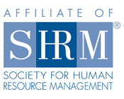
Award Criteria

Montana SHRM Council members will vote on nominees according to how the nominee:

- Demonstrated leadership in serving on committees, task forces, and/or special projects related to developing HR management programs;
- Demonstrated leadership in implementing HR management programs within and beyond his/her HR organization;
- Contributed to the advancement of the HR profession; and
- Contributed to the advancement of MT SHRM’s mission through the participation in association activities, projects, committees, etc.

2018 Montana Human Resource Leader of the Year Ballot

Name of Nominee:
Organization:
Title:
Mailing Address:
Phone Number:
Email:

Description:

Name of Nominator:
Organization:
Chapter:
Mailing Address:
Phone Number:
Email:

Please return ballot to:

Ronda Wakefield
Flathead Chapter of SHRM
2018 MT SHRM Workforce Development Director
nwmthrsolutions@centurylink.net
Questions? Call 406-250-1120

